Holy Trinity

Headington Quarry

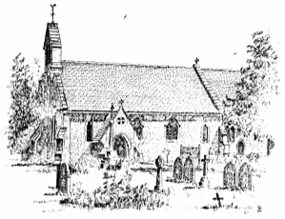

Tenth Sunday After Trinity

13th August 2023
Words of welcome.

Hymn 283

Fill your hearts with joy and gladness,
sing and praise your God and mine!
Great the Lord in love and wisdom,
might and majesty divine!
He who framed the starry heavens
knows and names them as they shine.

Praise the Lord, his people, praise him!
Wounded souls his comfort know;
those who fear him find his mercies,
peace for pain and joy for woe;
humble hearts are high exalted,
human pride and power laid low.

Praise the Lord for times and seasons,
cloud and sunshine, wind and rain;
spring to melt the snows of winter
till the waters flow again;
grass upon the mountain pastures,
golden valleys thick with grain.

Fill your hearts with joy and gladness,
peace and plenty crown your days;
love his laws, declare his judgments,
walk in all his words and ways;
he the Lord and we his children:
praise the Lord, all people, praise!
Timothy Dudley-Smith (b. 1926) based on Psalm 147

Please stand
The president says

In the name of the Father
and of the Son
and of the Holy Spirit
Amen

The Greeting

Grace, mercy and peace
from God our Father
and the Lord Jesus Christ be with you
and also with you.
Prayers of Penitence
A minister says

God so loved the world
that he gave his only Son Jesus Christ
to save us from our sins, to be our advocate in heaven,
and to bring us to eternal life.
Let us confess our sins in penitence and faith,
firmly resolved to keep God’s commandments
and to live in love and peace with all.

Silence is kept.

Most merciful God,
Father of our Lord Jesus Christ,
we confess that we have sinned
in thought, word and deed.
We have not loved you with our whole heart.
We have not loved our neighbours as ourselves.
In your mercy
forgive what we have been,
help us to amend what we are,
and direct what we shall be;
that we may do justly,
love mercy,
and walk humbly with you, our God.
Amen

The president says

Almighty God,
who in Jesus Christ has given us
a kingdom that cannot be destroyed,
forgive you your sins,
open your eyes to God's truth,
strengthen you to do God's will
and give you the joy of God’s kingdom,
through Jesus Christ our Lord.
Amen.

Gloria in Excelsis

Glory to God, we give you thanks and praise
Of heavenly joy and earthly peace we sing.
We worship you, to you our hearts we raise,
Lord God, Almighty Father, heavenly King.

Lord Jesus Christ, the Father’s only Son,
You bore for us the load of this world’s sin.
O Lamb of God, your glorious victory won,
Receive our prayer, grant us your peace within.

Alone, O Christ, you are the only Lord,
At God’s right hand, in majesty most high.
Who with the Spirit, worshipped and adored
With all the heavenly host, we glorify.
Tune: ‘Woodlands’

The Collect
Let your merciful ears, O Lord,
be open to the prayers of your humble servants;
and that they may obtain their petitions
make them to ask such things as shall please you;
through Jesus Christ your Son our Lord,
who is alive and reigns with you,
in the unity of the Holy Spirit,
one God, now and for ever. Amen.
Please be seated

The Liturgy of the Word

First Reading: Romans 10. 5-15
Moses writes concerning the righteousness that comes from the law, that ‘the person who does these things will live by them.’ But the righteousness that comes from faith says, ‘Do not say in your heart, “Who will ascend into heaven?” ’ (that is, to bring Christ down) ‘or “Who will descend into the abyss?” ’ (that is, to bring Christ up from the dead). But what does it say?
‘The word is near you,
on your lips and in your heart’
(that is, the word of faith that we proclaim); because if you confess with your lips that Jesus is Lord and believe in your heart that God raised him from the dead, you will be saved. For one believes with the heart and so is justified, and one confesses with the mouth and so is saved. The scripture says, ‘No one who believes in him will be put to shame.’ For there is no distinction between Jew and Greek; the same Lord is Lord of all and is generous to all who call on him. For, ‘Everyone who calls on the name of the Lord shall be saved.’
But how are they to call on one in whom they have not believed? And how are they to believe in one of whom they have never heard? And how are they to hear without someone to proclaim him? And how are they to proclaim him unless they are sent? As it is written, ‘How beautiful are the feet of those who bring good news!’
This is the word of the Lord.

Thanks be to God.

Please stand.

Hymn 690

Jesus is Lord! Creation’s voice proclaims it,
for by his power each tree and flower was planned and made.
Jesus is Lord! The universe declares it;
sun, moon and stars in heaven cry: Jesus is Lord!

Jesus is Lord! Jesus is Lord!
praise him with Alleluias, for Jesus is Lord!

Jesus is Lord! Yet from his throne eternal
in flesh he came to die in pain on Calvary ’s tree.
Jesus is Lord! From him all life proceeding,
yet gave His life a ransom, thus setting us free:

Jesus is Lord! O’er sin the mighty conqueror,
from death he rose and all his foes shall own his name.
Jesus is Lord! God sends his Holy Spirit
to show by works of power that Jesus is Lord:

David John Mansell (b.1936)

Gospel Reading
Please stand. We repeat the refrain.

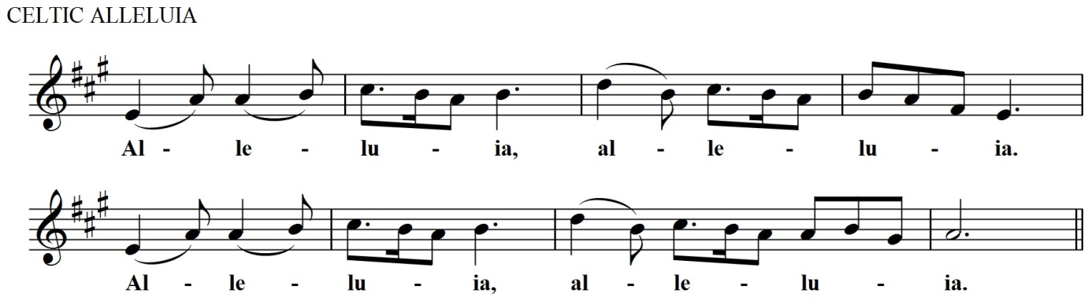

Hear the Gospel of our Lord Jesus Christ according to Matthew.
Glory to you, O Lord.

Gospel reading: Matthew 14.22-33
Immediately he made the disciples get into the boat and go on ahead to the other side, while he dismissed the crowds. And after he had dismissed the crowds, he went up the mountain by himself to pray. When evening came, he was there alone, but by this time the boat, battered by the waves, was far from the land, for the wind was against them. And early in the morning he came walking towards them on the lake. But when the disciples saw him walking on the lake, they were terrified, saying, ‘It is a ghost!’ And they cried out in fear. But immediately Jesus spoke to them and said, ‘Take heart, it is I; do not be afraid.’
Peter answered him, ‘Lord, if it is you, command me to come to you on the water.’ He said, ‘Come.’ So Peter got out of the boat, started walking on the water, and came towards Jesus. But when he noticed the strong wind, he became frightened, and beginning to sink, he cried out, ‘Lord, save me!’ Jesus immediately reached out his hand and caught him, saying to him, ‘You of little faith, why did you doubt?’ When they got into the boat, the wind ceased. And those in the boat worshipped him, saying, ‘Truly you are the Son of God.’
This is the Gospel of the Lord.

Praise to you, O Christ

Sermon
Revd Peter Boulton-Lea

Nicene Creed
Please stand

Let us declare our faith in God.

We believe in one God,
the Father, the Almighty,
maker of heaven and earth,
of all that is,
seen and unseen.
We believe in one Lord, Jesus Christ,
the only Son of God,
eternally begotten of the Father,
God from God, Light from Light,
true God from true God,
begotten, not made,
of one Being with the Father;
through him all things were made.
For us and for our salvation he came down from heaven,
was incarnate from the Holy Spirit and the Virgin Mary
and was made man.
For our sake he was crucified under Pontius Pilate;
he suffered death and was buried.
On the third day he rose again
in accordance with the Scriptures;
he ascended into heaven
and is seated at the right hand of the Father.
He will come again in glory to judge the living and the dead, and his kingdom will have no end.

We believe in the Holy Spirit,
the Lord, the giver of life,
who proceeds from the Father and the Son,
who with the Father and the Son is worshipped and glorified,
who has spoken through the prophets.
We believe in one holy catholic and apostolic Church.
We acknowledge one baptism for the forgiveness of sins.
We look for the resurrection of the dead,
and the life of the world to come.
Amen.
Prayers of Intercession

Please sit or kneel. The following response may be used:

Lord, hear us.
Lord, graciously hear us.

We pray for those who are sick or in particular need:

Natalia Stoneman, Jemima, Naomi Lawrence,

Kate Samuel, Grace, Judith, Josie, Kitty Datta,

Polly Friedhoff, Bob Southgate, Benji, Margaret Whipp, Astrid Brooke, Caroline Winwood, Penny.

Those who have died recently:

Rosemary Herklots, Caroline Wilson, Evelyn Clare

Those whose anniversary of death falls at this time:
Bill Whelan, Thomas Miles, Jacquie Cherry, William Hancock,
Richard Davies, Gary Whiting, John Simpson.

And at the end

Merciful Father,
accept these prayers
for the sake of your Son,
our Saviour Jesus Christ.
Amen.

The Peace
Please stand

To crown all things there must be love

to bind all together and complete the whole.

Let the peace of Christ rule in our hearts.

The peace of the Lord be always with you

and also with you.

A minister says

Let us offer one another a sign of peace

All may exchange a sign of Peace

Hymn 610

Christ is the world’s true light,

its captain of salvation,

the daystar clear and bright

of every land and nation;

new life, new hope awakes,

where peoples own his sway;

freedom her bondage breaks,

and night is turned to day.

In Christ all races meet,

their ancient feuds forgetting,

the whole round world complete,

from sunrise to its setting:

when Christ is throned as Lord,

lands shall forsake their fear,

to ploughshare bear the sword,

to pruning-hook the spear.

One Lord, in one great name

unite us all who own thee;

cast out our pride and shame

that hinder to enthrone thee;

the world has waited long,

has travailed long in pain;

to heal its ancient wrong,

come, Prince of Peace, and reign!

George Wallace Briggs (1875-1959)

Taking of the Bread and Wine

As the grain once scattered in the fields
and the grapes once dispersed on the hillside
are now reunited on this table in bread and wine,
so, Lord, may your whole Church soon be gathered together
from the corners of the earth
into your kingdom. Amen.

The Eucharistic Prayer

Please sit or stand as you are most comfortable

The Lord be with you
and also with you.

Lift up your hearts.
We lift them to the Lord.

Let us give thanks to the Lord our God.
It is right to give thanks and praise.
Father, you made the world and love your creation.
You gave your Son Jesus Christ to be our Saviour.
His dying and rising have set us free from sin and death.

And so we gladly thank you,
with saints and angels praising you, and singing:
Holy, holy, holy is the Lord;
holy is the Lord God almighty.
Holy, holy, holy is the Lord;
holy is the Lord God almighty,
who was, and is and is to come.
Holy, holy, holy is the Lord!

Blessed, blessed, blest the one who comes;
Blest the one who comes in the Lord’s name.
Blessed, blessed, blest the one who comes;
Blest the one who comes in the Lord’s name.
who was, and is and is to come.
Holy, holy, holy is the Lord!

We praise and bless you, loving Father,
through Jesus Christ, our Lord;
and as we obey his command,
send your Holy Spirit,
that broken bread and wine outpoured
may be for us the body and blood of your dear Son.

On the night before he died he had supper with his friends
and, taking bread, he praised you.
He broke the bread, gave it to them and said:
Take, eat; this is my body which is given for you;
do this in remembrance of me.
When supper was ended he took the cup of wine.
Again he praised you, gave it to them and said:
Drink this, all of you;
this is my blood of the new covenant,
which is shed for you and for many for the forgiveness of sins.
Do this, as often as you drink it, in remembrance of me.

So, Father, we remember all that Jesus did,
in him we plead with confidence his sacrifice
made once for all upon the cross.
Bringing before you the bread of life and cup of salvation,
we proclaim his death and resurrection
until he comes in glory.

Great is the mystery of faith:
Christ has died:
Christ is risen:
Christ will come again.

Lord of all life,
help us to work together for that day
when your kingdom comes
and justice and mercy will be seen in all the earth.
Look with favour on your people,
gather us in your loving arms
and bring us with the Blessed Virgin Mary and all the saints
to feast at your table in heaven.
Through Christ, and with Christ, and in Christ,
in the unity of the Holy Spirit,
all honour and glory are yours, O loving Father,
for ever and ever.
Amen.
The Lord’s Prayer

Please sit or kneel

As our saviour taught us, so we pray

Our Father in heaven,
hallowed be your name,
your kingdom come, your will be done,
on earth as in heaven.
Give us today our daily bread.
Forgive us our sins
as we forgive those who sin against us.
Lead us not into temptation
but deliver us from evil.
For the kingdom, the power
and the glory are yours,
now and for ever. Amen.

Breaking of the Bread

We break this bread
to share in the body of Christ.

Though we are many, we are one body,
because we all share in one bread.
Agnus Dei

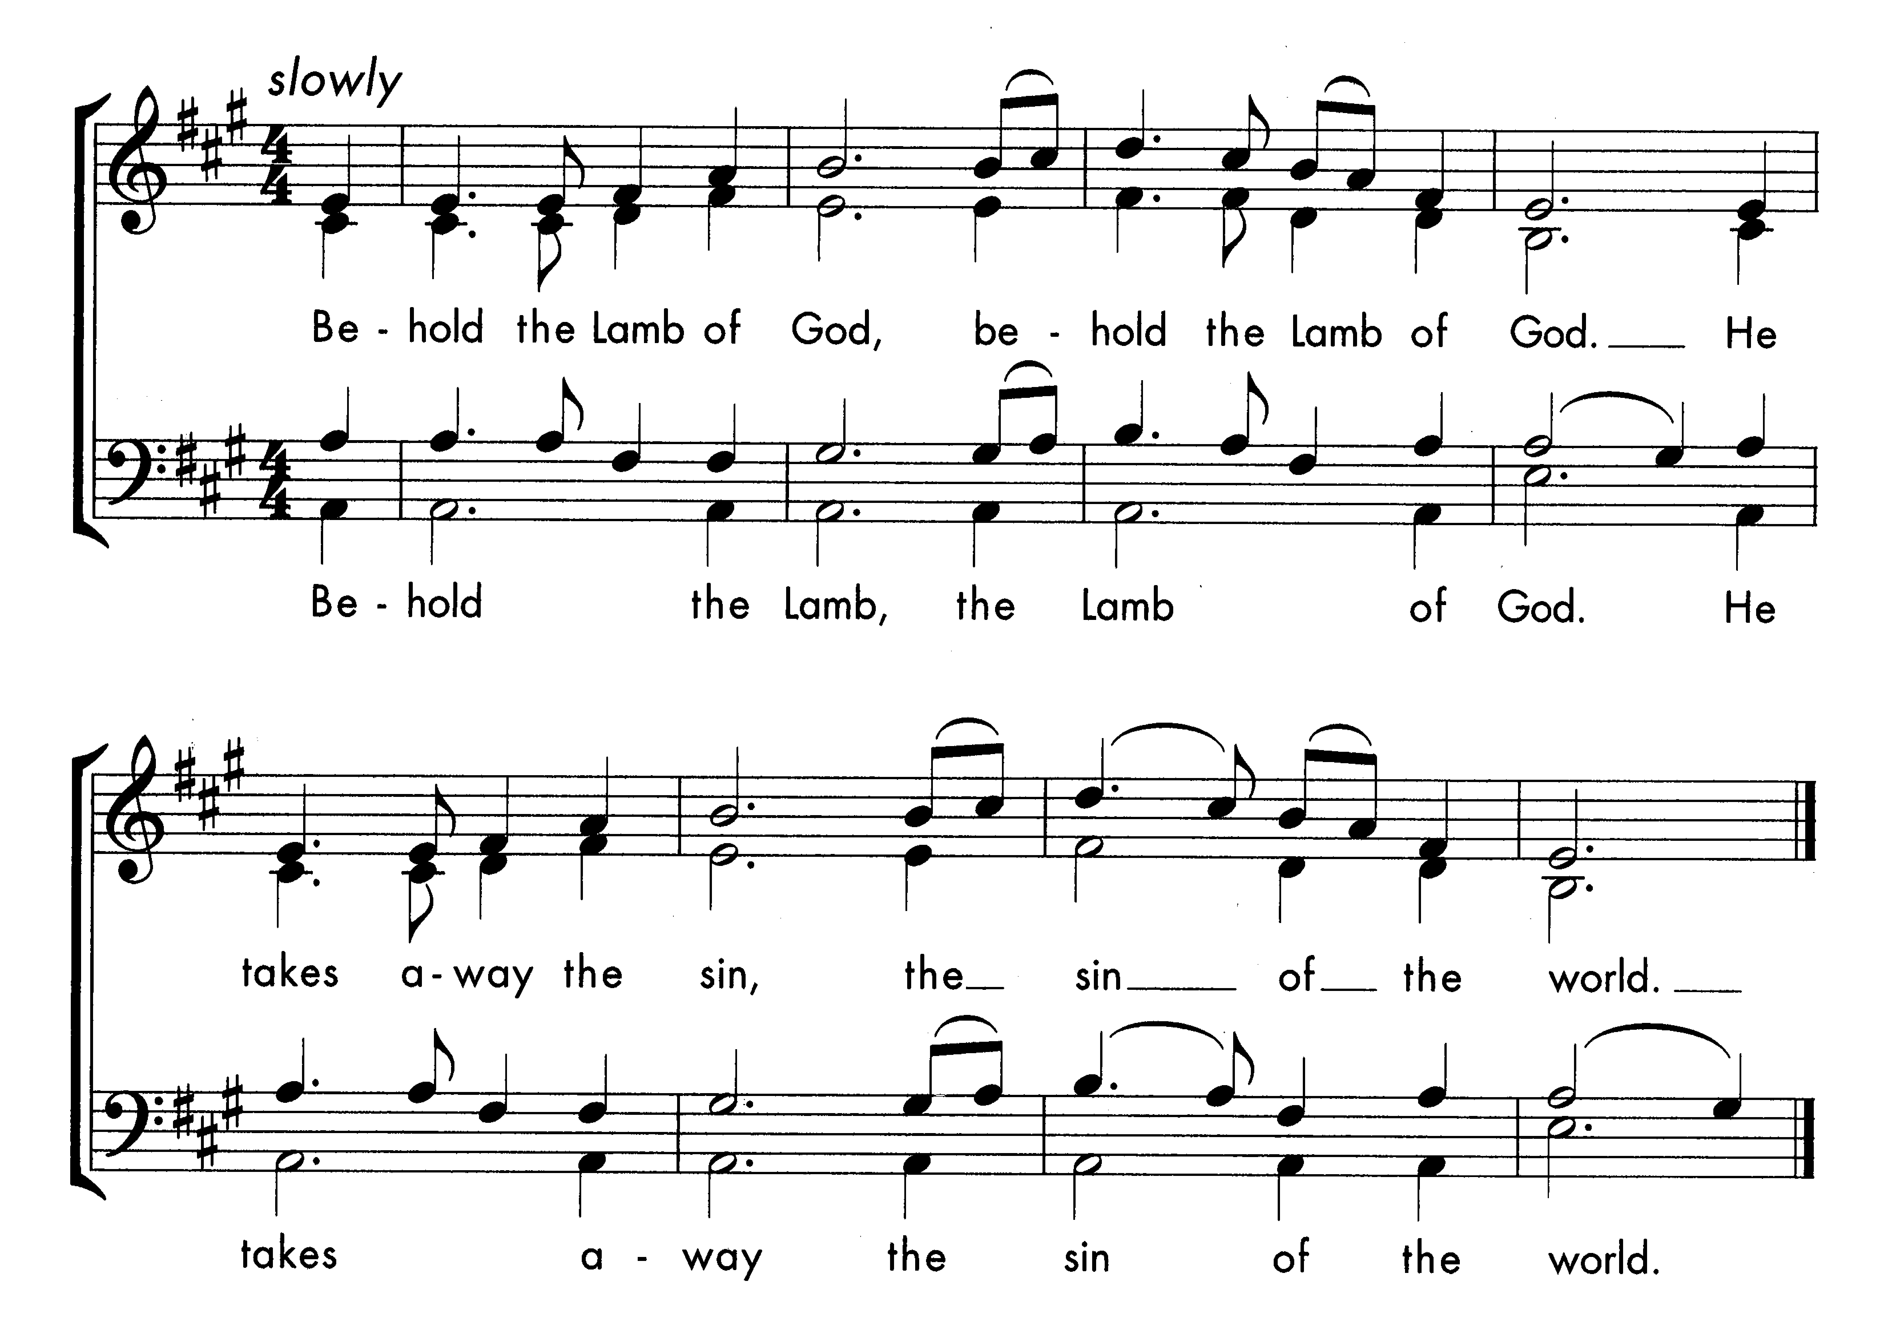

Giving of Communion
God’s holy gifts
for God’s holy people.
Jesus Christ is holy,
Jesus Christ is Lord,
to the glory of God the Father.

This is God’s table and all are welcome. Please follow the directions of the steward and follow the one-way system back to your seat. Those sitting towards the back will be invited to come forwards first. If you are wearing a mask, it is most practical if you remove it before receiving communion. The chalice is being administered from the Lady Chapel step. If you wish to receive the chalice, please hold the base of the chalice and guide it towards your lips – the person administering the chalice will not let go of it in the process. Please do not dip your wafer into the chalice. Please note that there is no obligation to take the chalice and it is fine still to receive communion in one kind only (the bread). If you do not wish to receive communion and would prefer a blessing instead, please do come forwards as well.

Hymn 664

How sweet the name of Jesus sounds
in a believer's ear!
It soothes his sorrows, heals his wounds,
and drives away his fear.

It makes the wounded spirit whole,
and calms the troubled breast;
'tis manna to the hungry soul,
and to the weary, rest.

Dear name! the rock on which I build,
my shield and hiding-place,
my never-failing treasury filled
with boundless stores of grace.

Jesus! my Shepherd, Brother, Friend,
my Prophet, Priest, and King,
my Lord, my Life, my Way, my End,
accept the praise I bring.

Weak is the effort of my heart,
and cold my warmest thought;
but when I see thee as thou art,
I'll praise thee as I ought.

Till then I would thy love proclaim
with every fleeting breath;
and may the music of thy name
refresh my soul in death.

John Newton (1725-1807)

Prayer after Communion

God of our pilgrimage,
you have willed that the gate of mercy
should stand open for those who trust in you:
look upon us with your favour
that we who follow the path of your will
may never wander from the way of life;
through Jesus Christ our Lord. Amen.

Father of all,

we give you thanks and praise,

that when we were still far off

you met us in your Son and brought us home.

Dying and living, he declared your love,

gave us grace, and opened the gate of glory.

May we who share Christ’s body live his risen life;

we who drink his cup bring life to others;

we whom the Spirit lights give light to the world.

Keep us firm in the hope you have set before us,

so we and all your children shall be free,

and the whole earth live to praise your name;

through Christ our Lord.

Amen.

The Sending Out

Please stand

Hymn 814

Thy hand, O God, has guided

thy flock, from age to age;

the wondrous tale is written

full clear, on every page;

our fathers owned thy goodness,

and we their deeds record;

and both of this bear witness:

one Church, one faith, one Lord!

Thy heralds brought glad tidings

to greatest, as to least;

they bade men rise, and hasten

to share the great King's feast;

and this was all their teaching,

in every deed and word,

to all alike proclaiming

one Church, one faith, one Lord!

When shadows thick were falling,

and all seemed sunk in night,

thou, Lord, didst send thy servants,

thy chosen sons of light.

On them and on thy people

thy plenteous grace was poured,

and this was still their message:

one Church, one faith, one Lord.

Through many a day of darkness,

through many a scene of strife,

the faithful few fought bravely,

to guard the nation's life.

Their Gospel of redemption,

sin pardoned, man restored,

was all in this enfolded:

one Church, one faith, one Lord.

And we, shall we be faithless?

Shall hearts fail, heads hang down?

Shall we evade the conflict,

and cast away our crown?

Not so: in God's deep counsels

some better thing is stored;

we will maintain, unflinching,

one Church, one faith, one Lord.

Thy mercy will not fail us,

nor leave thy work undone;

with thy right hand to help us,

thy victory shall be won;

and then, by men and angels,

thy name shall be adored,

and this shall be their anthem:

one Church, one faith, one Lord.

Edward Hayes Plumptre (1821-1891)

The Blessing
The peace of God,
which passes all understanding,
keep your hearts and minds
in the knowledge and love of God,
and of his Son Jesus Christ our Lord;
and the blessing of God almighty,
the Father, the Son, and the Holy Spirit,
be among you and remain with you always.
Amen.

The Dismissal
Go in peace to love and serve the Lord.
In the name of Christ. Amen.

Voluntary: War March of the Priests - Felix Mendelssohn (1809 – 1847)

Please do join us for refreshments outside (or inside if raining!)
Please take this booklet away with you, and recycle it when you have finished with it. We no longer pass the collection plate around during the service, but you are welcome to use the collection plate at the back of church, or the contactless machine, if you would like to make a donation to support the work of our church. If you would like to sign up to regular monthly giving, please visit www.hthq.uk/giving-to-the-church for more information.
Copyright: Common Worship © The Archbishops’ Council 2000, 2006. CCL no 234208.
Notices: August 13th
Sunday August 13th: Tenth Sunday after Trinity
8am Holy Communion
10am Parish Eucharist please note that Forest Sunday School will take a break in August and return September 3rd.
Sunday August 20th: Eleventh Sunday after Trinity
8am Holy Communion
10am Parish Eucharist

Midweek Services
Please note that Morning Prayer will break during August and resume on Monday 4th September. The Lady Chapel is still set aside for quiet prayer and reflection and anyone is welcome to stop by and use the prayer resources during this time.

Fundraising Concert: Hymns of Creation
We are delighted to announce that our fundraising concert on July 29th raised £740 towards our church building project. Warm thanks are owed to Prof William Phemister for offering this concert to support our project, and to Magdalen College Chapel for hosting us so generously.

2023: A time to build: Exciting Updates!
Finance We are delighted to announce that our loan application from Methodist Chapel Aid has been approved! This means that we now have the finance in place to complete our project.

The application process was helped considerably by the incredible generosity shown by those who have contributed towards our latest and final fundraising appeal to finance the loan. Thank you so much to all who have been able to contribute, and to everyone who has supported the process with their prayers. The total amount pledged so far is £116,000, towards a loan of £250,00. If you haven't yet been able to send in a pledge form, we would still love to hear from you! Those who have sent in pledge forms will be contacted in due course about the next steps.

If you would like to make a donation directly into our building fund account, the details are:
Account name: HTHQ
Sort Code: 20-65-20.
Account no: 83117634
(Please include your name as a reference)

Graves and memorials The vicar and churchwardens are keen to ensure that all those who tend graves or memorials in the churchyard are able to have any questions or concerns they have with regards to the building works answered where possible and kept in touch with the development’s progress. If this applies to you or anyone else you know please let Helen in the Parish Office have the contact details so that you can be kept in touch with any relevant information. office@hthq.uk or 01865 762931 Tues - Thurs 8.30 – 12 noon only.
Prayer requests Please continue to hold the project in your prayers as we look to finalise the start date. As the psalmist writes: 'unless the Lord builds the house, those who labour build it in vain' (Psalm 127.1). We ask you all to pray especially for wisdom for our architect and contractors, and for peaceful relations with our neighbours and local residents affected by the work.
God of vision and hope,
we thank you for our church building;
a place of prayer and pilgrimage,
witnessing to your love and presence in our midst.
We pray for our plans to develop the building
to further the work of your kingdom in this and future generations.
We pray for the guidance, resources and skills we need
to bring the project to completion,
and that we would be united in vision and focus
as we work towards this goal,
in the name of Jesus Christ our Cornerstone.
Amen.

Rosemary Herklots a much loved member of our congregation died on 1st August. Her funeral will be held here in church on Friday September 1st at 10.30am. All are welcome to attend, and refreshments will be offered at the Cornerstone Church in Quarry High Street after the service. Our thoughts and prayers go with her family and many friends.

Newsletter The deadline for the next online newsletter is Thursday 31 August. If you have any items and photos to contribute, please email them to Yue-Yi Hwa at newsletter@hthq.uk. Thank you.

Date for Diary 3rd September we look forward to welcoming Bishop Steven to our Parish Eucharist at 10am as we bless the start of our building work and give thanks for the progress we have made so far. Please come along to this special service!

Evensong on Sunday 3rd September is likely to be the final evensong before the building works take place. We would like to extend the invitation to any of the congregation who would like to join the choir for this service only, even if you never have before. There will be a practice the Thursday before (31st August at 7:30pm), and before the Evensong at 4:45pm. Help, coaching and music will be provided, and the music will be taken from traditional Evensong repertoire. Please talk to Andrew Patterson, or any choir member if you are thinking about it – we would be delighted see you.

Philosophy Club After the success of the Philosophy Club and the enjoyment of those who attended the Philosophy Club is looking to start again in September. Aiming to meet once a fortnight to take a dive through various philosophers and their ideas from Anaximander and Parmenides right through to contemporary figures such as Nozick and Rawls. The course is aimed for those who have no prior knowledge of philosophy and is kept at a relaxed, informal pacing. Newcomers are more than welcome to attend, as are those who attended the first run-through of the course (there will be a few differences this time round) and there is no pressure to attend every session, if you would prefer to only dip in for the session which grab your interest you are more than welcome to do so. Sessions typically last for 1 hour consisting of a short talk introducing the topic followed by questions and discussion from the group. Exact day and time to be confirmed. If you are interested in joining us or have any questions, please contact Richard Churchill at richardc8@msn.com

Welcome Tea: Sunday 17th September 3pm-4.30pm.
The vicar and churchwardens warmly invite you to a welcome tea on Sunday 17th September in the Vicarage garden (weather depending). This is an opportunity for new members of the church to find out more about church life in a friendly and informal setting (over tea and cake!). We are casting a wide net this time because we haven’t been able to hold the event for the past few years: please contact Helen Day (office@hthq.uk) if you are able to come.

Church Flowers The flower team hope you are enjoying the flowers this summer. We come in every Friday to clear out the old ones and make new arrangements. As you may be aware we do not receive any money from the church for flowers and rely solely on donations from the congregation, and we are running very low on funds as some of our older donors are no longer with us.
We are very aware of increases in the cost of living but would welcome any donations from you. Remember that you can donate in memory of loved ones, for birthdays anniversaries etc. Please contact Margaret Woodcock on Ox. 761588 or Helen Nowicki on Ox. 434644 if you are able to donate towards the flower fund. Thank you.

Stay & Play drop-in playtime from 10am to 12 noon 14th to 18th August in the Coach House for small children and parents/carers/grandparents/nannies/childminders. There will be all sorts of toys and activities aimed at children aged 6 and under, as well as refreshments for children and adults.There is a suggested donation of £1 per family. Further details from Anna Brown, Joan Jones, and Elizabeth Knight.

Asylum Welcome Please do not leave any fresh produce or fruit and vegetables but donate eg cooking oil, tinned tomatoes, milk (UHT) and tinned fish. Please put items in the crate at the back of church. You can find a list of all the items that are needed on this page: https://www.asylum-welcome.org/food/. Thank you for your support.

Eco Resources List: To view the August/September recommended resources go to: https://www.hthq.uk/eco-church-resources/
(Hilary Rollin, Eco Church Group)

Eco Tips Eco Tip of the Week: Use loose leaf tea (in a tea pot or tea infuser) rather than tea bags. This not only makes for a reduction in wrapping, used tea leaves are a welcome addition to the compost heap, and besides, our bodies will thank us for avoiding ingesting the plastic contained in most tea bags. (Hilary Rollin for Eco Church Group)

Pastoral care team Are you in need of support or would you like to talk to someone? We rely on you to let us know of anyone who is ill, or in hospital or who might welcome a visit. Please contact any of the clergy (numbers below) or Helen Day, Janet Masters, or Anne Tarassenko.

Holy Trinity Headington Quarry
An open door between heaven and earth,
showing God’s love to all.

As the Anglican parish in Headington Quarry, Risinghurst and Wood Farm, we are here for every local resident. Our church is open every day. We hope that you will find God’s peace as you come to pray or just sit and rest awhile. If you have questions about the Christian faith or would like to find out more about church life, please get in touch:
Contact us
Vicar: Revd Dr Laura Biron-Scott
vicar@hthq.uk 01865 762835
Associate Priest: Revd Prof Rob Gilbert
associatepriest@hthq.uk
Curate: Revd Emily Hockliffe Essex
curate@hthq.uk 07979 931889
Parish Office: office@hthq.uk 01865 762931
Churchwardens: wardens@hthq.uk
Website: www.hthq.org.uk
Church post code for emergencies: OX3 8LQ

